1. What are the conditional operators in Java?

Answer: we have 3 types of conditional operators.

* Logical – AND operator (&&)
* Logical - OR Operator (||)
* Ternary Operator (?:)

1. What are the types of operators based on the number of operands?

Answers:

* arithmetic operators.
* relational operators.
* logical operators.
* Assignment Operators
* Logical Operators.
* Unary Operators

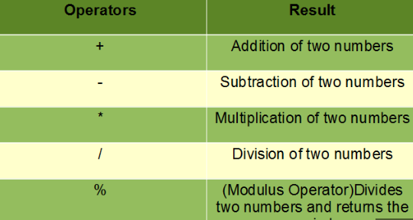

1. what is the use of switch case in java programming.

Answer:

The switch case in java is used to select one of many code blocks for execution. Break keyword: As java reaches a break keyword, the control breaks out of the switch block. The execution of code stops on encountering this keyword, and the case testing inside the block ends as the match is found.

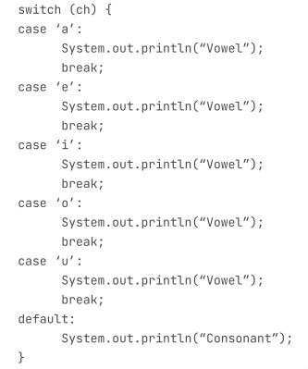

1. What are the priority levels of arithmetic operation in Java?

Answer:

The operator precedence is responsible for evaluating the expressions. In Java, parentheses() and Array subscript[] have the highest precedence in Java. For example, Addition and Subtraction have higher precedence than the Left shift and Right shift operators.

1. What are the conditional statements and use of conditional statements in Java?

Answer:

Java has following conditionla statements:

1. if Statement

2. else Statement

3. if else Ternary

4. Nested if-else

5. Switch Statement

Use if to specify a block of code to be executed, if a specified condition is true. Use else to specify a block of code to be executed, if the same condition is false. Use else if to specify a new condition to test, if the first condition is false.

1. What is the syntax of if else statement?

Answer:

Syntax:

If (Condition)

{

Statement 1

}

else

{

Statement 2

}

1. What are the 3 types of iterative statements in Java?

Answer:

There are 3 types of iterative statements in Java;

* The while loop.
* The for loop.
* The do while loop.

1. Write a difference between for loop and do while loop?

Answer:

For loop:

* It is known as entry controlled loop
* Initialization and updating is the part of the syntax.

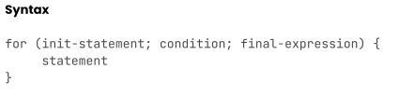

While loop:

* Initialization and updating is not the part of the syntax.
* A while loop is a loop that runs through its body, known as a while statement as long as preferment condition is evaluated as true.

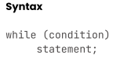

1. Write a program to print a numbers from 1 to 10?

//   write a program to print numbers from 1 to 10

import javax.lang.model.util.ElementScanner6;

public class operator {

    public static void main(String[] args) {

      System.out.println(" Pringting number using for loop \n ");

     for(int i=1; i<=10;i++)   /// print number form 1 to 10 using for loop.

     {

      System.out.println(i+" ");

     }

     System.out.println(" Pringting number using do while loop \n ");

     int num=1;

     while(num<=10)

     {

      System.out.println(num+" ");

      num++;

     }

   }

}